

SCHOOL OF ELECTRONICS AND COMMUNICATION ENGINEERING

A COURSE BASED REPORT (IOT)
ON
“HUMANOID ROBOT USING ARDUINO UNO”
Submitted in fulfillment of the requirements for the award of the Degree of

BACHELOR OF TECHNOLOGY
IN
ARTIFICIAL INTELLIGENCE AND MACHINE LEARNING

Submitted by
DIVYA.S (R24EA034)

Under the guidance of
Dr.Sankar Prasad Bag
Associate Professor
School of ECE, REVA University

February 2025
Rukmini Knowledge Park, Kattigenahalli, Yelahanka, Bengaluru-560064
www.reva.edu.in

DECLARATION

I, DIVYA.S (R24EA034) student of B.Tech, belong to School of Computing and Information Technology, REVA University, declare that this IOT Report “Humanoid Robot using Arduino UNO” is the result of work done by us under the supervision of Dr.Sankar Prasad Bag, Associate Professor School of ECE, REVA University, Bengaluru.

We are submitting this Report in partial fulfillment of the requirements for the completion of Course in IOT and Applications in I-Semester of Bachelor of Technology in Artificial Intelligence and machine learning by the REVA University, Bengaluru during the academic year 2024-2028.

(Signature of the Students)

February 2025

Certified that this work submitted by DIVYA.S (R24EA034) has been carried out under our guidance and the declaration made by the candidates is true to the best of our knowledge.

Signature of Faculty Signature of Director
Date: February 2025 Date: February 2025
Official Seal of the School

Name of the Examiner with affiliation Signature with Date
1.
2.
List of Contents |  | Page No.
List of Figures and Tables
Abstract
Chapter-I | 1.1 Introduction
 | 1.2 Objectives
 | 1.3 Layout
Chapter-II | 2.1 Literature Survey
 | 2.2 Comparison Table
Chapter-III | 3.1 Methodology of Work
 | 3.2 Results and Analysis
Chapter-IV | 4.1 Conclusion
 | 4.2 Future Scope
References

LIST OF FIGURES AND TABLES
Figure 1: Flowchart of working of Humanoid robot using Arduino UNO -------------
Figure 2: Working of Humanoid Robot. ---------------------------------------------------
Figure 3: Results and Analysis--------------------------------------------------------------
Table 1: Comparison Table--------------------------------------------------------------
ABSTRACT
Humanoid Robots are the integration of bionics, brain-inspired intelligence, mechanics, control and simulation of human model that mimic human actions, professionally designed to function and interact with human tools and environment. This project presents the design and development of a humanoid robot controlled via Bluetooth using an Arduino Uno microcontroller. The robot is powered by DC motors, which are driven by L239D motor driver modules to enable smooth and precise movements. Communication between the user and the robot is facilitated by the HC-05 Bluetooth module, allowing for wireless control through a Smartphone using Arduino Bluetooth controller app. The flexibility and adaptability of this human-friendly robot makes it an integral part in modern IoT applications aims to provide insights into the implementation of low-cost humanoid robotics using Arduino-based systems, emphasizing ease of control, modularity, and scalability for future enhancements.

Chapter-I
Introduction
  - Introduction
In the ever-evolving landscape of robotics, humanoid robots stand out for their ability to mimic human actions and behaviors. These robots are designed to perform tasks that require dexterity, mobility, and real-time responsiveness, making them invaluable for applications in automation, assistive technology, and human-robot collaboration. The increasing accessibility of microcontroller-based platforms, such as Arduino, has significantly lowered the entry barrier for developing cost-effective humanoid robots, fostering innovation in both academic and industrial settings.
This project explores the development of a humanoid robot utilizing an Arduino Uno microcontroller as the central processing unit, interfacing with DC motors and L239D motor drivers. The incorporation of the HC-05 Bluetooth module facilitates wireless communication, allowing real-time control of the robot using external devices such as smart phones. By leveraging modular hardware and open-source software, this project aims to establish a flexible and scalable humanoid robotic system that can serve as a foundation for future advancements, including sensor integration, artificial intelligence, and autonomous navigation.
The significance of this project lies in its ability to demonstrate fundamental principles of robotic motion, control systems, and wireless communication while offering practical insights into real-world applications. By focusing on the efficient coordination of motor actuation and Bluetooth-based command execution, the humanoid robot embodies a multidisciplinary approach to robotics, encompassing embedded systems, mechatronics, and human-machine interaction. The findings from this project can contribute to the development of more sophisticated robotic systems with enhanced autonomy and adaptability, paving the way for further research in humanoid robotics.

Objectives
- Automated Learning
- Wireless communication integration
- Motor control and actuation
- Human –robot interactions
- Microcontroller programming.

- Layout 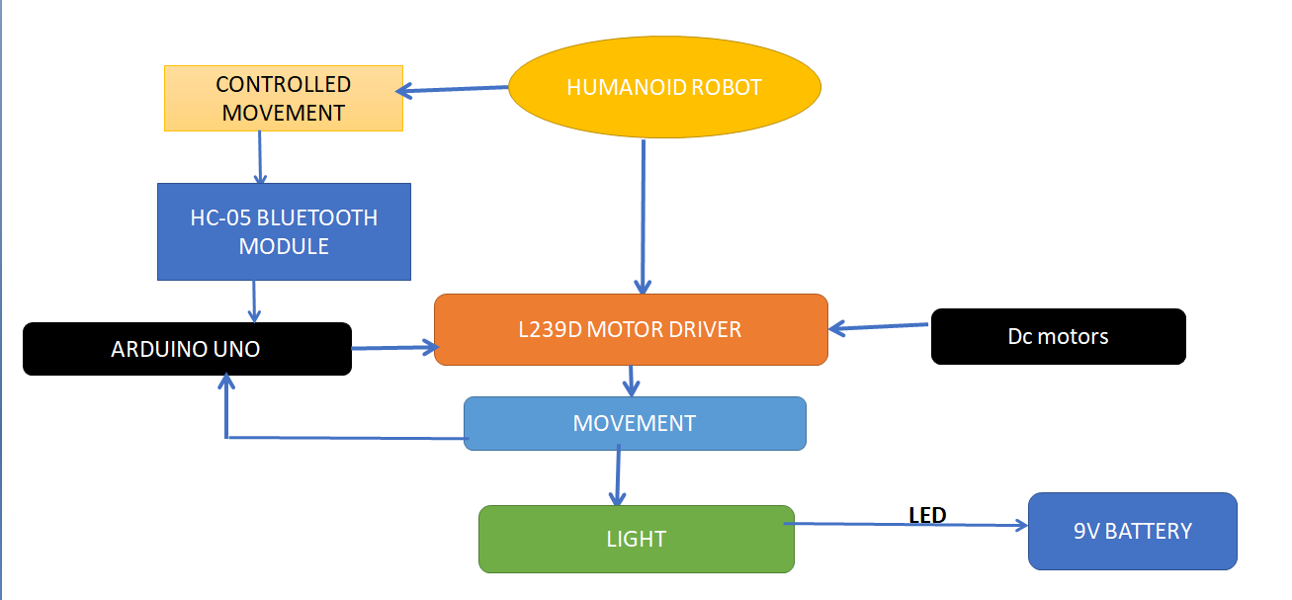

Fig1. Flowchart of Model
Chapter–II
Review on Existing Literature
2.1 Literature Survey
Recent Developments and Human-Robot Interaction Humanoid robots have undergone significant evolution in the past decade, with advancements in artificial intelligence, machine learning, and sensor technologies. Microcontroller-Based Humanoid Robots
Researchers have explored the use of microcontrollers such as Arduino, Raspberry Pi, and ESP32 to control humanoid robots. Arduino Uno, being a widely used open-source microcontroller, has been extensively adopted for small-scale robotic projects. It provides an easy-to-use platform for integrating motor drivers (L298N, L293D) and communication modules such as HC-05 Bluetooth to enable wireless control. Motion Control Using DC motors.In existing humanoid robotic systems, DC motors and servo motors are commonly employed for movement. Servo motors provide precise angular motion, making them ideal for robotic arms and legs, while DC motors, coupled with motor drivers, are used for mobility. Research highlights the use of PID (Proportional-Integral-Derivative) control algorithms to improve the stability and smoothness of robotic motion. The integration of Bluetooth, Wi-Fi, and RF modules has enabled wireless communication in humanoid robots. The HC-05 Bluetooth module is widely used due to its low power consumption and reliable connectivity with smart phones and computers. Studies have shown that voice recognition, gesture control, and mobile applications significantly enhance user interaction with humanoid robots.

2.2ARDUINO UNO
The Arduino Uno is an open-source microcontroller board based on the microchip ATmega328P microcontroller and developed by arduino.cc. The board is equipped with sets of digital and analog I/O pins that may be interfaced to various expansion boards. Its accessibility and versatility make it an ideal tool for students in exploring robotics and enhancing their creativity.
.

2.3 Comparison Table

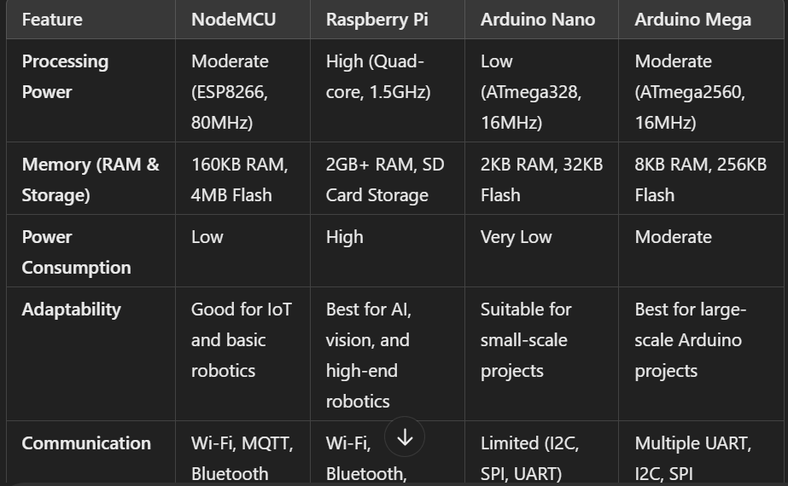
Chapter-III
Work, Results and Analysis
4.1 Work
Figure 2: Working of Humanoid Robot
4.2 Results and Analysis
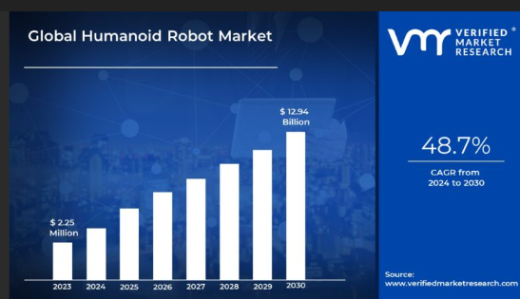

Chapter-IV: Conclusion & Future Scope
Conclusion
Humanoid robots have a unique set of applications and features that distinguish them from other types of robots. One of the primary advantages of humanoid robots is their ability to interact with humans in a natural and intuitive way, enabling them to collaborate with humans in various tasks and environments. They can be used in service industries such as hotels, restaurants, and retail stores, providing customers with a unique and personalized experience. Additionally, humanoid robots can be used in education and training, healthcare and rehabilitation, space exploration, search and rescue, entertainment and performance, and social companionship.
Humanoid robots also possess unique features such as bipedal locomotion, dexterous manipulation, facial recognition and expression, and advanced sensors and perception. These features enable them to navigate through complex environments, manipulate objects with precision and dexterity, recognize and express human-like emotions, and perceive their environment through advanced sensors. Furthermore, humanoid robots can be used in disaster response, scientific research, and other applications that require human-like intelligence, dexterity, and interaction. Overall, the unique combination of features and applications of humanoid robots makes them an exciting and rapidly evolving field of research and development.
5.2 Future Scope
- Advanced Mobility and Dexterity: Humanoid robots will develop more advanced mobility and dexterity, enabling them to perform complex tasks that require fine motor skills.
- Integration with IoT and Smart Homes: Humanoid robots will be integrated with IoT devices and smart homes, enabling them to control and interact with various devices and systems.
- Use in Education and Training: Humanoid robots will be used more extensively in education and training, providing interactive and immersive learning experiences
- Healthcare & Assistance: Medical Assistance: Helping doctors with surgeries and patient monitoring.
- Industrial Automation: Enhancing production efficiency by performing repetitive tasks. Assisting in logistics, sorting, and moving goods.
- Military & Defense: Search & Rescue Missions: Operating in disaster-stricken areas for rescue operations. Surveillance & Patrolling: Monitoring borders and high-security zones.

References
- "Humanoid Robotics: A Reference" – Editors: Antonio Bicchi, Paolo Dario, Raja Chatila (Springer, 2019): Covers advancements in humanoid robot design, applications, and future trends.
- "Introduction to Autonomous Robots" – Nikolaus Correll, Bradley Hayes, and Bradley M. Spell (MIT Press, 2022):Discusses robotics applications, including humanoid robots in healthcare, industry, and space.
- "Artificial Intelligence and Robotics" – Edited by Shuo Yang (IntechOpen, 2021):Explores AI integration with humanoid robots and their future role in automation.
- "Robotics: Modelling, Planning and Control" – Bruno Siciliano, Lorenzo Sciavicco, Luigi Villani, Giuseppe Oriolo (Springer, 2010):A fundamental book on robotics theory and applications in industrial and service robots.
- "Rise of the Robots: Technology and the Threat of a Jobless Future" – Martin Ford (Basic Books, 2015):Discusses the impact of humanoid robots on the economy and job market.

Research Papers & Articles:
- "The Future of Humanoid Robots: Research and Applications" – International Journal of Humanoid Robotics, 2021,Explores advancements and future possibilities in humanoid robots.
- "Humanoid Robotics: Past, Present, and Future" – IEEE Transactions on Robotics, 2020Discusses historical evolution, current trends, and future developments in humanoid robotics.
Websites & Online Reports:
- Boston Dynamics Blog (www.bostondynamics.com).Features insights into state-of-the-art humanoid robots like Atlas and their future applications.
- World Economic Forum Report on Robotics and AI (2023) (www.weforum.org),Covers the impact of humanoid robots on industries and the future of work.
- NASA Robotics Research & Development (www.nasa.gov)
Discusses the use of humanoid robots in space exploration and planetary colonization.
11."NimbRo-OP2X: Affordable Adult-sized 3D-printed Open-Source Humanoid Robot for Research"
Authors: Grzegorz Ficht, Hafez Farazi, Diego Rodriguez, et al.
12. "Perception for Humanoid Robots"
Authors: Arindam Roychoudhury, Shahram Khorshidi, Subham Agrawal, Maren Bennewitz
13. "Advancements in Humanoid Robots: A Comprehensive Review and Future Prospects".

